Simple Sales Dashboard Design — Superstore Sales

Objective:
- To build an interactive sales dashboard showing performance by product, region, and month.
- To visualize key trends in sales and profit for better business understanding.
Tools Used:
- Power BI (for visualization)
- Dataset: Superstore_Sales.csv
Dashboard Features:
- Line chart for monthly sales trend
- Bar/Donut charts for region and category performance
- Slicer for category or region

Top Sales Months:
- December and September had the highest sales, showing seasonal growth.
Segment Performance:
- The Consumer segment generated the majority of total sales, followed by Corporate and Home Office.
Category Analysis:
- Office Supplies contributed the highest profit, while Technology maintained steady sales throughout the year.
Overall Sales Summary:
- Total Sales: 2.3M
- Total Profit: 286.4K
- Indicates a strong profit margin and consistent demand.

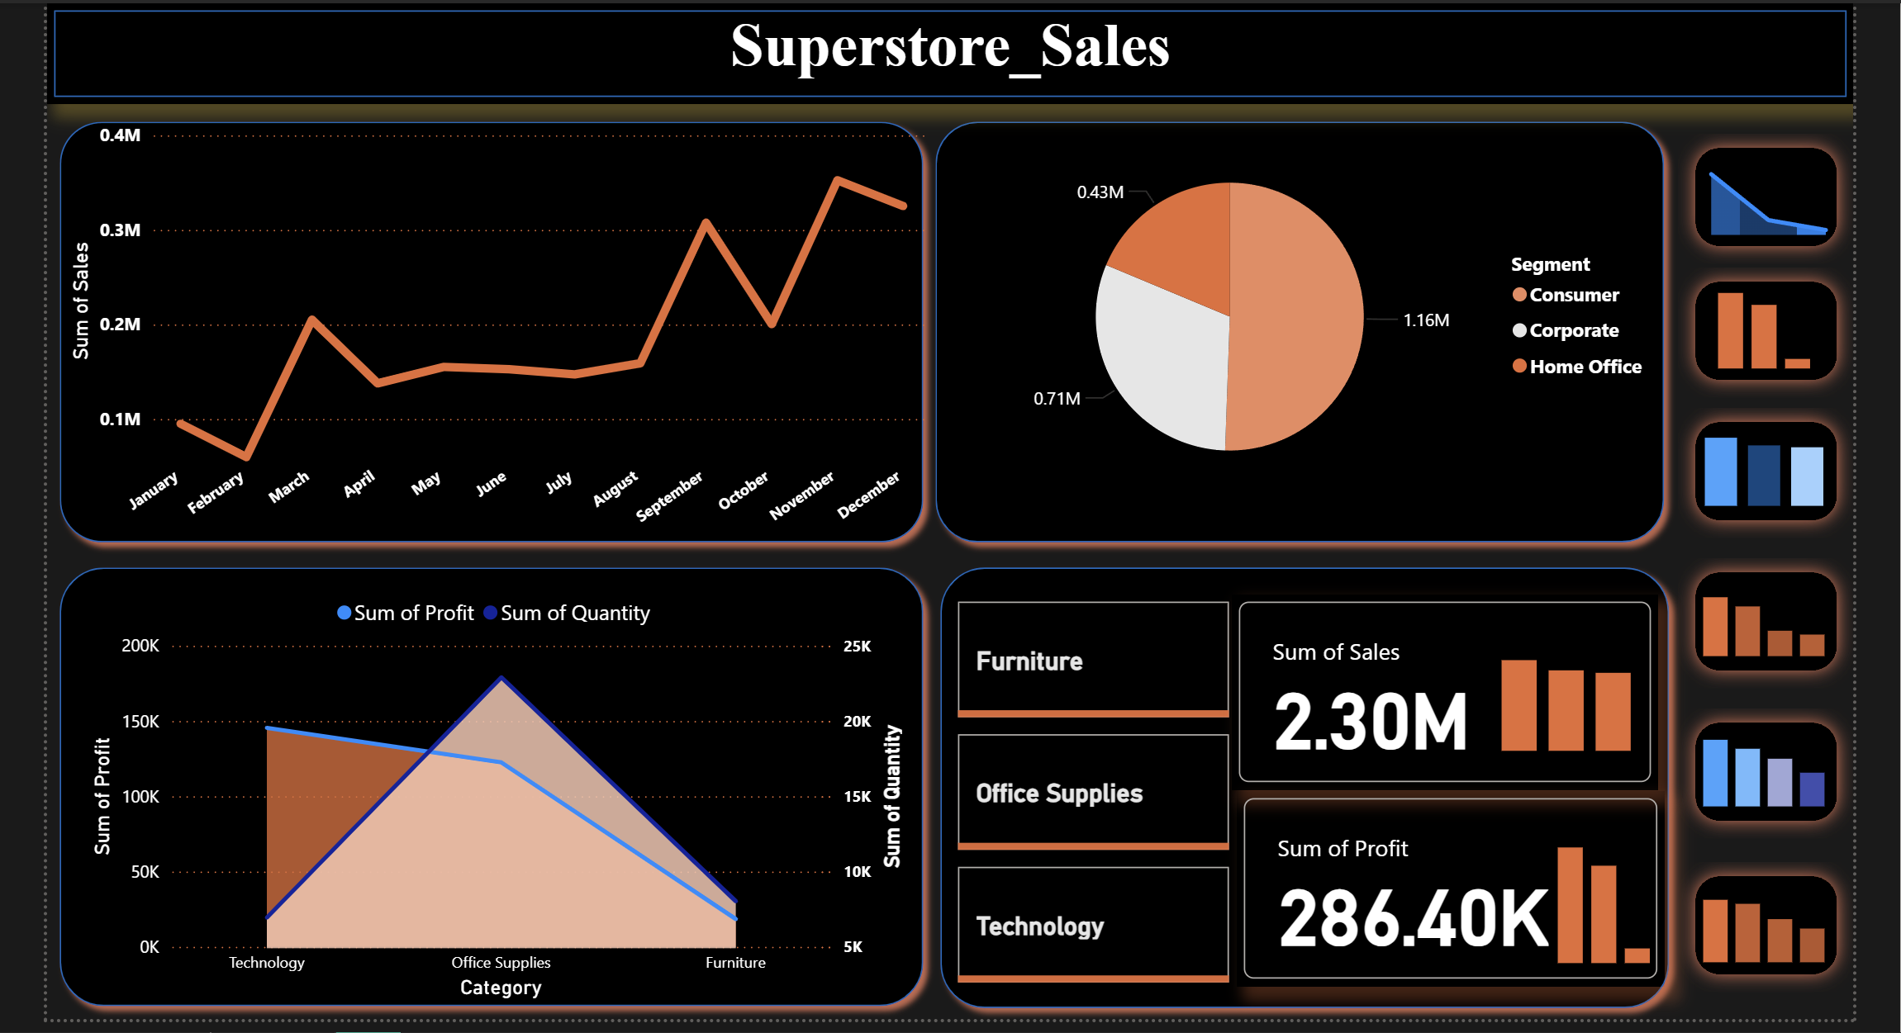

Conclusion & Key Learnings
- The dashboard provides a clear visual understanding of sales and profit distribution.
- It highlights key performing months, segments, and product categories.
- Interactive filters improve user experience and allow focused analysis.
- This task enhanced understanding of Power BI dashboard design, data visualization, and insight reporting.

